PPP

- Chetty et al
  - Loans to small businesses have little impact on employment rates (3-4 pp)
- Bartik et al
  - PPP loans led to a positive but imprecise effect on employment
  - Administering the loans via private banks allowed for rapid delivery of funds, but limited targeting since pre-existing connections between banks and firms determined which firms would firms would benefit from the program
- Granja et al
  - PPP had not substantial effect on employment or hours worked
  - Businesses are maintaining loaned PPP funds in bank accounts as precautionary savings until they are ready to resume activities
  - Their results are not consistent with the idea that PPP served as a large-scale alternative to unemployment insurance for delivering funds to affected workers
- Autor et al
  - PPP increased the level of employment at eligible firms by between 2 percent and 4.5 percent through the end of May.
  - These estimates imply that the PPP boosted the level of private employment in the U.S. by between 1.4 and 3.2 million, with a mid-point of 2.3 million.

Stimulus Checks
- FIM MPC
  - 0.7 total
  - Q2 is 0.3
    - Want to change to 0.35
- Chetty et al
  - Stimulus checks increased spending among low-income households but not much for high-income households
- Karger et al
  - Average MPC of 0.4
- Baker et al
  - Spending increased by 29% of the stimulus amount in the 10 days after receiving payment, mainly driven by food and non-durables
  - MPC of 0.25-0.35
- Coibon et al
  - Most respondents report that they primarily saved or paid down debts with their transfers, with only about 15 percent reporting that they mostly spent it.
  - U.S. households report having spent approximately 40 percent of their checks on average
- Misra et al
  - Aggregate MPC of 0.43
  - $722 of a $1,678 stimulus (average stimulus) is spent within the first four days of receipt.

Unemployment Insurance
- Garza Casado et al
  - We find that higher replacement rates lead to significantly more consumer spending – even with increases in the unemployment rate – consistent with the goal of the fiscal stimulus.
  - A 1% increase in the unemployment rate is associated with a decrease in spending of more than 6%, while a 1% increase in the replacement rate is associated with an increase in spending of over 0.5%.
- Cox et al
  - stimulus checks and expanded UI benefits represent a larger share of monthly income for low-income workers than for high-income workers, and would thus naturally explain the more rapid recovery in spending we observe for low-income workers.
  - As a result of the CARES Act, UI benefits are much more generous in level and duration, and available to many more workers. Furthermore, sizable stimulus checks were also sent out in April. These income supports might buffer against labor income-related spending declines if this stimulus continues. The more rapid recovery of spending for low-income households suggest this channel is at work
- Patterson
  - 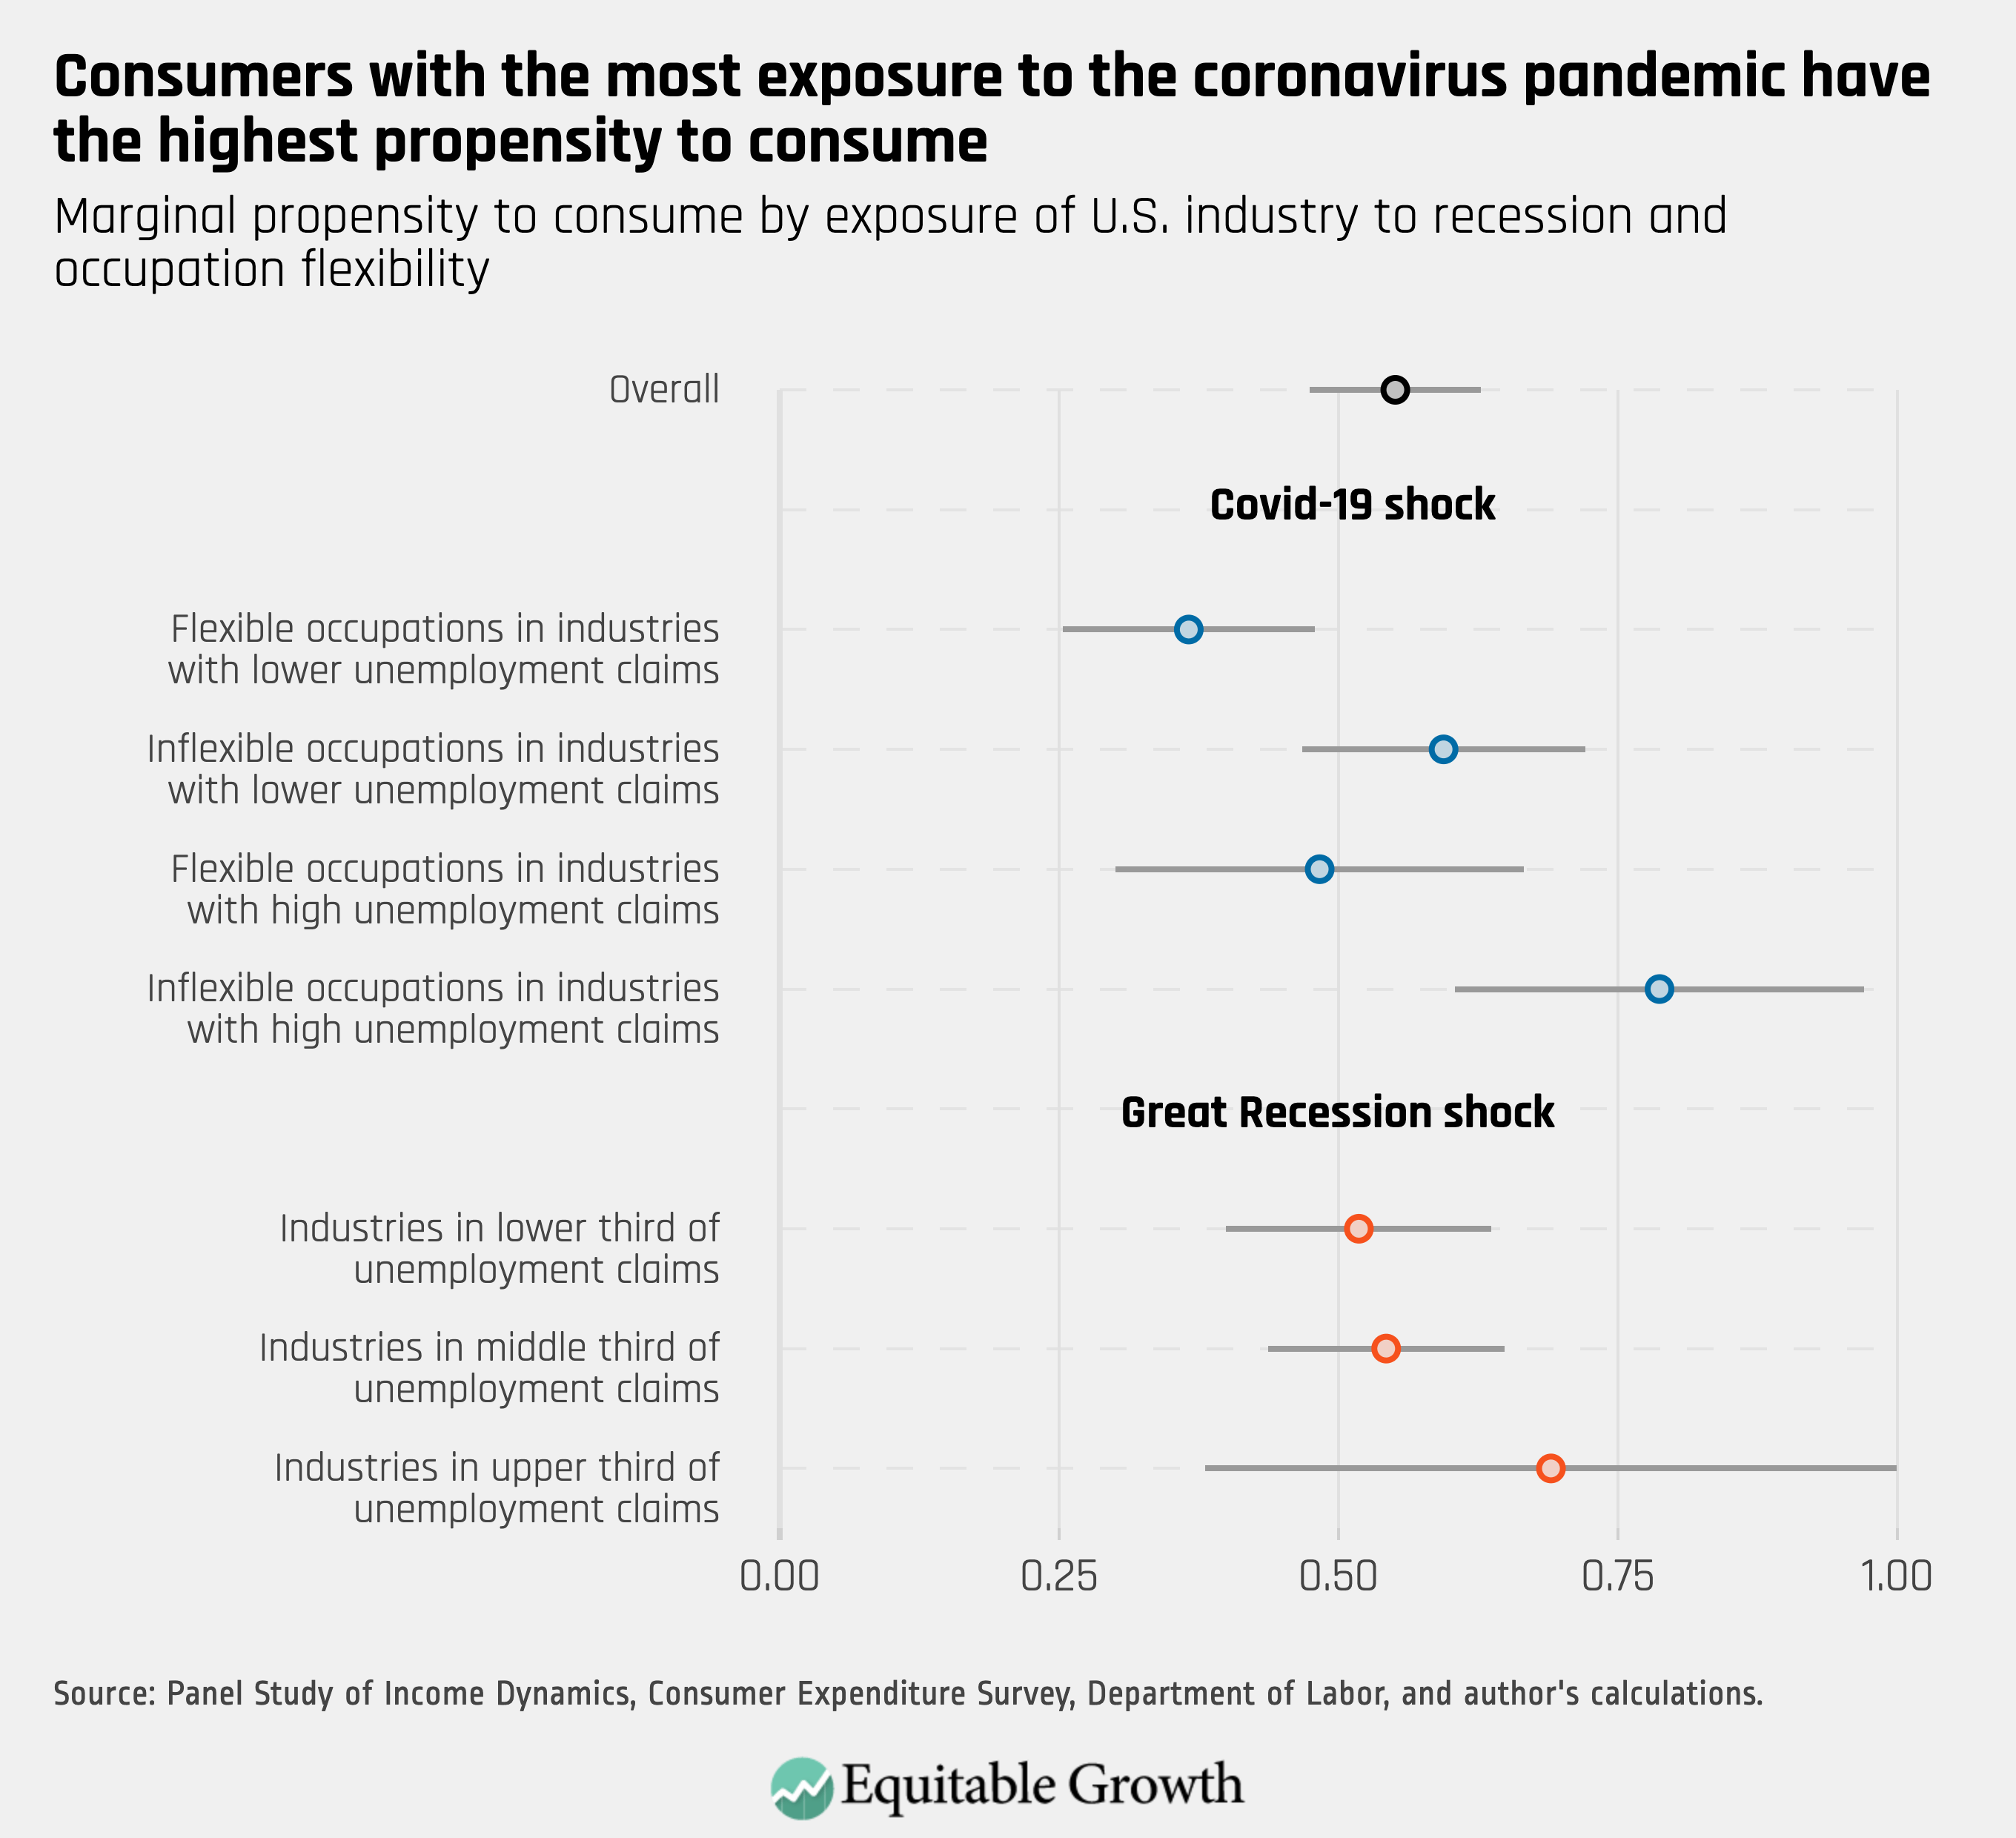
- Ganong et al (2019)
  - For every $1 of UI total bank account outflows rise by $0.83
  - 6 months

How Did COVID-19 and Stabilization Policies Affect Spending and Employment?

A New Real-Time Economic Tracker Based on Private Sector Data
Raj Chetty, John N. Friedman, Nathaniel Hendren, Michael Stepner, and the Opportunity Insights Team†

June 17, 2020

- Stimulus checks increase spending among low-income households
- Loans to small businesses have little impact on employment rates (3-4 percentage points)

The Targeting and Impact of Paycheck Protection Program Loans to Small Businesses
Bartik et al
- PPP loans led to a positive but imprecise effect on employment.
- Administering the loans via private banks allowed for rapid delivery of
funds, but limited targeting since pre-existing connections between banks and firms determined which firms would firms would benefit from the program

DID THE PAYCHECK PROTECTION PROGRAM HIT THE TARGET?
Granja et al, May 2020
- PPP had not substantial effect on employment or hours worked
- Businesses are maintaining loaned PPP funds in bank accounts as precautionary savings until they are ready to resume activities
- Their results are not consistent with the idea that PPP served as a large-scale alternative to unemployment insurance for delivering funds to affected workers

An Evaluation of the Paycheck Protection Program Using Administrative Payroll Microdata
Autor, et al. July 22, 2020
- PPP increased the level of employment at eligible firms by between 2 percent and 4.5 percent through the end of May.
- These estimates imply that the PPP boosted the level of private employment in the U.S. by between 1.4 and 3.2 million, with a mid-point of 2.3 million.

Heterogeneity in the Marginal Propensity to Consume: Evidence from Covid-19 Stimulus Payments

Karger et al. May 29, 2020

- They find an average MPC of 0.4 for stimulus payments

Income, Liquidity, and the Consumption Response to the 2020 Economic Stimulus Payments
Baker et al. May, 2020
- Spending increased by 29% of the stimulus amount in the 10 days after receiving payment, mainly driven by food and non-durables

